3 Good Products:
1- Headphones (Hear Clearly in transport and noise cancellation)
2- Oppo Reno 6 (Very good mobile - keep its performance over very long time)
3- PlayStation 5 (Entertain with Fifa and COD)
3 Bad Products:
1- Fake AirPods (Bad Quality of Audio and don’t last long)
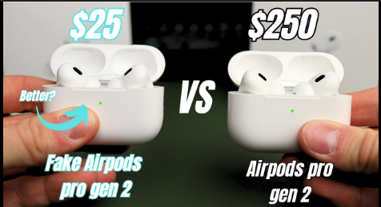
2- Sonic cup (can’t drink with it)

3- Large Charger for Lenovo Laptops (So Heavy)

3 Good Websites:
1- Notion (Manage tasks in efficient way simple UI & UX)
2- GitHub (Work with others and manage team work efficiently Remotely – simple UX)
3- Yotube (A lot of Good Videos and Good Educational Content and simple UX & UI)
3 Bad Websites:
1- natgas (bad UX can’t pay gas pills easily and contain so many errors)
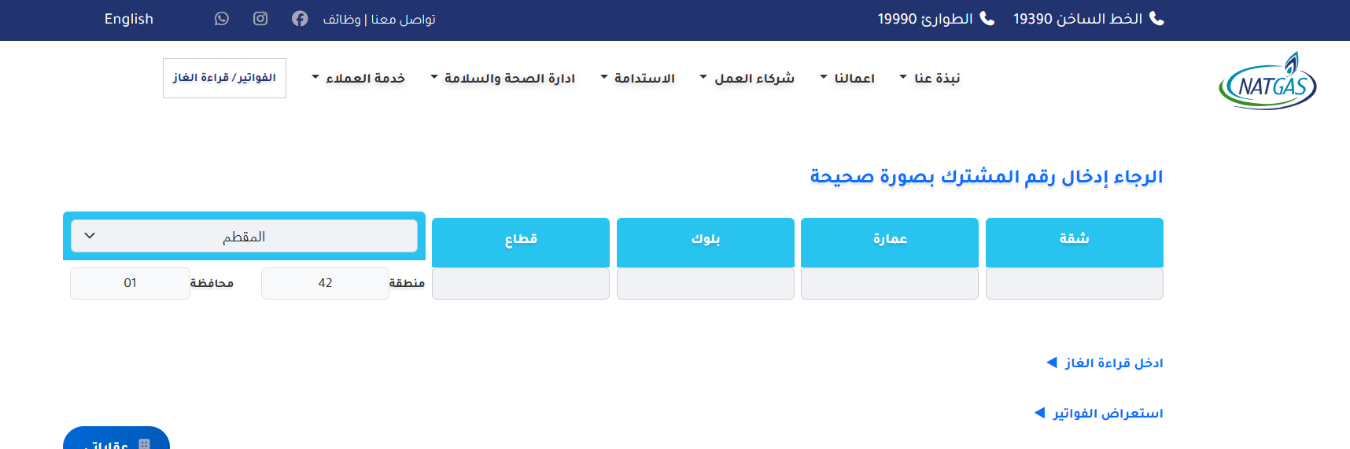
2- codeforces (bad in solving and submitting problems through it – bad UX)
3- Amazon (A lot of products in one screen so I feel distracted with so many products)

3 Good Mobile Apps:
1- Instagram (Good Reels related to me – easy UX)
2- WhatsApp (easy to message – simple UI & UX)
3- Instapay (simple use & transfer money in easy way and no time)
3 Bad Mobile Apps:
1- Maatloob (Bad Findable – Unexpected Errors)
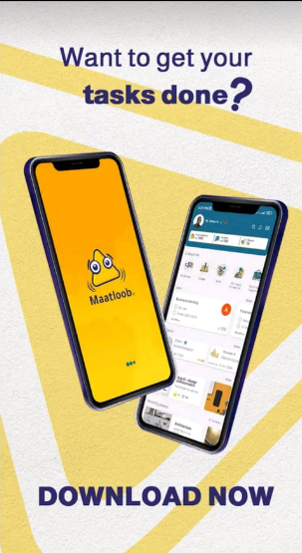
2- Facebook (A lot and condensed Posts – can’t change pass easily)
3- Truecaller (can’t set permissions easily take a lot of permission – bad UX a lot of ads)

